Español 1A Me llamo _______________________
Capítulo 2: Los pasatiempos Hoy es ________________________
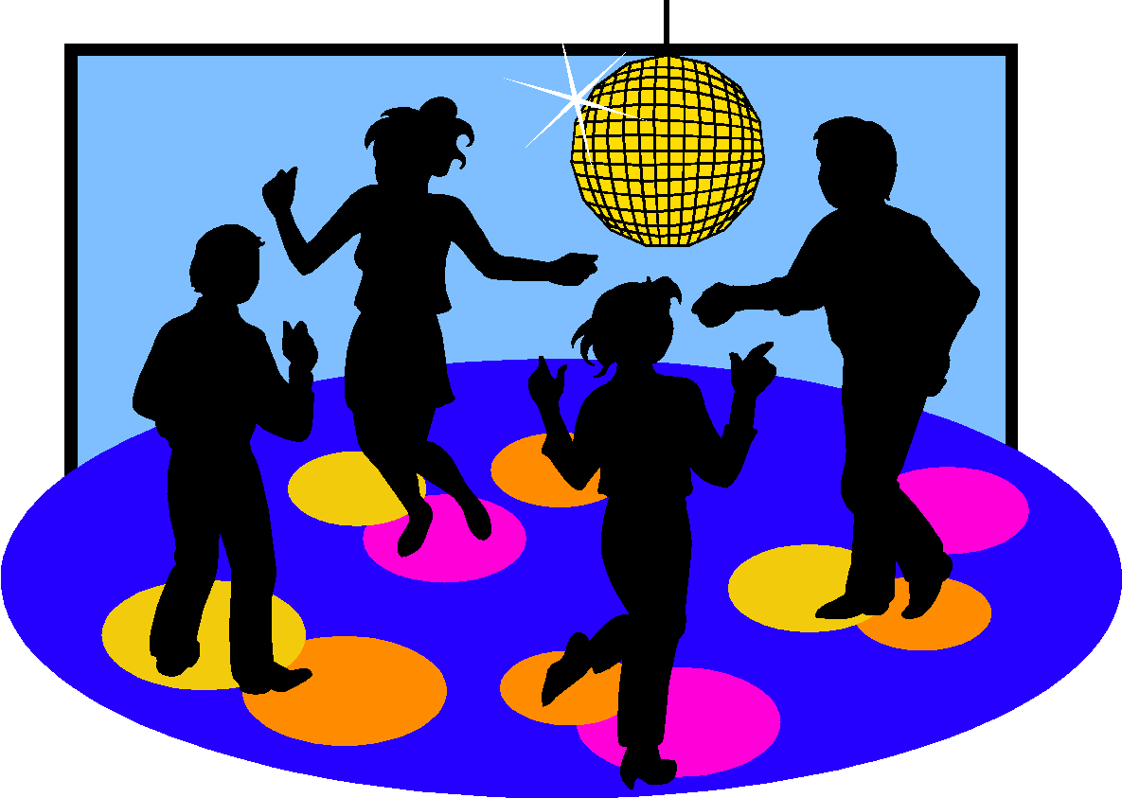
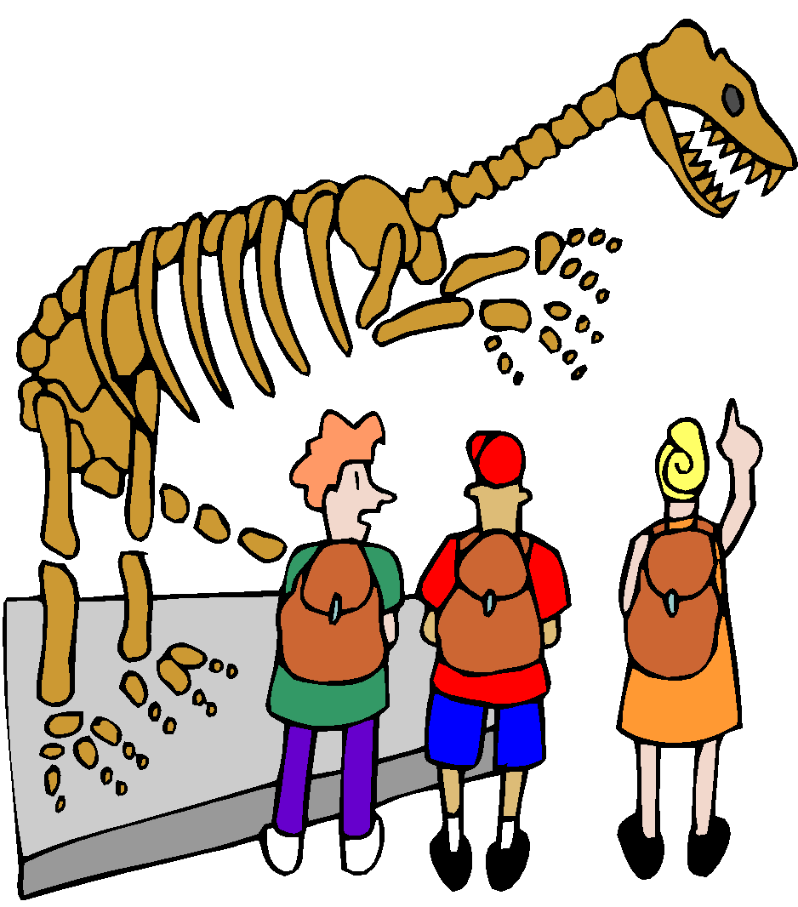
¡MAS PASATIEMPOS!
But we do more than just what we learned yesterday. Below there are different pastimes that many people like to do during their free time.

Grupo 2: (las actividades con el verbo «ir»)
1. ir al cine | To go to the movie theatre
2. ir al teatro | To go to the theatre
3. ir al museo | To go to the museum
4. ir a la playa | To go to the beach
5. ir al centro comercial | To go to the mall
6. ir a los clubs del colegio | To go to school clubs
7. ir al concierto | To go to a concert
8. ir a una discoteca | To go to a club
9. ir al partido de fútbol | To go to a soccer game
10. ir al café | To go to a café
11. ir de compras | To go shopping
12. ir de vacaciones  ir a parques de atracciones | To go on vacation  To go to an amusement park
13. ir a una fiesta | To go to a party

Escribe en español: ( Me gusta…)
1 I like to go to parties on Saturday night.

___________________________________________________________

2 I like to go on vacation with my family.

___________________________________________________________

3 I like to go to concerts in the summer .

___________________________________________________________

4 I like to take a walk on the beach in the summer.

___________________________________________________________

